# Online Gift Shopping

# (By III Year M.sc (2016-2017))

**2142194 Modi Khushboo D**

**2143207 Patel Meghal B**

**Internal Project Guide: Miss.Sonali Chakrabarty**

**Miss.Pinky Ruparel**

**Name of Company: Patel Gift Articles**

**Date of Submission: 20 April, 2017**

**Submitted To,**

**K.S. School of Business Management,**

**M.Sc. In Computer Application and Information Technology,**

**Gujarat University.**



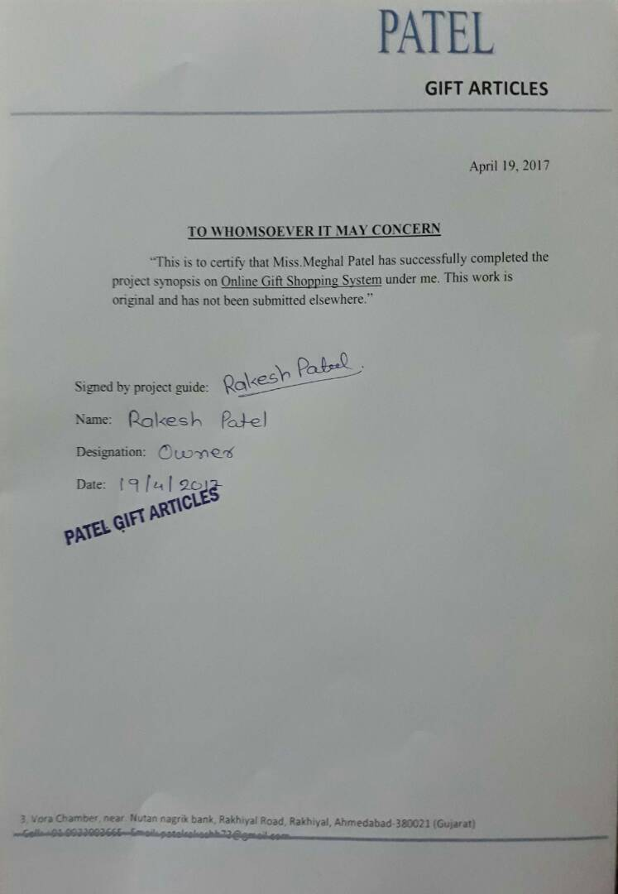

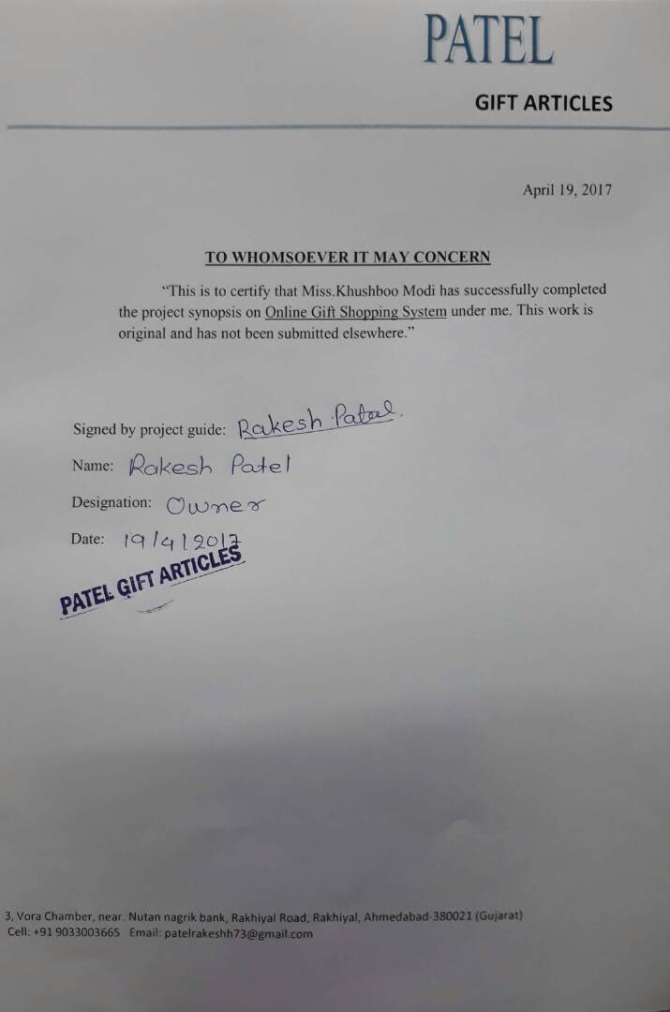

**Acknowledgement:**

The success and final outcome of this project required a lot of guidance and assistance from many people and we are extremely fortunate to have got this all along the completion of our project work. Whatever we have done is only due to such guidance and assistance and we would not forget to thank them.

We respect and thankful to K.S.S.B.M., for giving us an opportunity to do the project work in Web application and providing us all support and guidance which made us completes the project on time. We are extremely grateful to him for providing such a nice support and guidance though he had busy schedule managing the company affairs.

We would like to express our gratitude towards Course coordinator Department, **Dr. Kalyani Patel for** their kind co-operation and encouragement, which help us in this project.

**Group Id : - 71**

**Modi Khushboo (3194)**

**Patel Meghal (3207)**

# **INDEX**

|  |  |  |
| --- | --- | --- |
| SR.NO | TITLE | PAGE NO |
| **1** | **Company Profile** | **6** |
| **2** | Project Profile | **6** |
| **2.1** | **Current System** | **6** |
| **2.2** | **Proposed System** | **6** |
| **3** | **Tools and Platforms Used** | **7** |
| **4** | **System Flow Diagram, UML Diagram** | **9** |
| **5** | Data Dictionary | **18** |
| **6** | Input Output Design | **23** |
| **7** | Validation | **34** |
| **8** | Maintenance | **36** |
| **9** | Future Scope | **37** |

1. Company Profile

**Company Name** : Patel Gift Articles

**About**  :

This company works from 2003. This company provide the different types of gifts to the customers. In the starting days, this company works as small business but now-a-days company developed day by day. The company provide high quality products to the customers. The company provide such a products that satisfy the customer wants.

2. Project Profile

2.1 Current System

* There is no current system. The system is working manually.
* The current system is time consuming. Because it involves a lot of paperwork.
* To manually handle the system was very difficult task. But now-a-days computerization made easy to work.
* The existing System is not as much as user friendly as compare to our Proposed System.
* So people demand such a system that is reducing their time and buy the gifts easily at the home.

2.2 Proposed System

* In this fast generation nobody can go for shopping. Everything is available online.
* This is online website where the user registered themselves and uses this website.
* The goal of create this website very usable and user friendly service that can run on many internet browser.
* To overcome the disadvantage of current system we develop this system.
* In this system we can find gifts as we want.
* We can order the gifts and receives the gifts at home.
* We can send cards to anybody by email.
* The proposed system is highly secured, because for login the system it requires the username and password which is different for each user.
* It maintains Report for all criteria and transactions.
* Improve communication with customers.

**3. Tools and Platform Used**

* **Hardware Requirement:**

|  |  |
| --- | --- |
| **Parameters** | **Client Machine** |
| Processor | Pentium micro processor and above  Ppppppproces |
| RAM | 512 mb and above |
| Hard disk | 40 GB or above |
| Operating System | Windows 10 |

* **Software Requirement:**

|  |  |
| --- | --- |
| Front End | Sublime or Visual studio code |
| Back End | Mysql |
| Platform | PHP |
| Tools | JQuery |
| Web Service | JSON |

**4. UML Diagram**

**1) Use-Case Diagram:**

* **Symbol use in use case diagram**

|  |  |
| --- | --- |
| 1 Start |  |
| 2 Use case |  |

1.1) Use Case Diagram for User:



* 1. ) Use Case Diagram For Admin :



2) Activity Diagram:

* Symbol use in activity diagram

|  |  |
| --- | --- |
| 1 Start |  |
| 2 Activity |  |
| 3 Connector |  |
| 4 Decision |  |
| 5 End |  |

2.1) Activity Diagram for User:



* 1. ) Activity Diagram For Admin :



3) State Diagram:



4) Sequence Diagram:

* **Symbol use in sequence diagram**

|  |  |
| --- | --- |
| 1 Lifeline |  |
| 2 Sequence Message |  |
| 3 Return Message |  |
| 4 Activation |  |

4.1) Sequence Diagram for User:



4.2) Sequence Diagram for Admin:



5) Class Diagram:

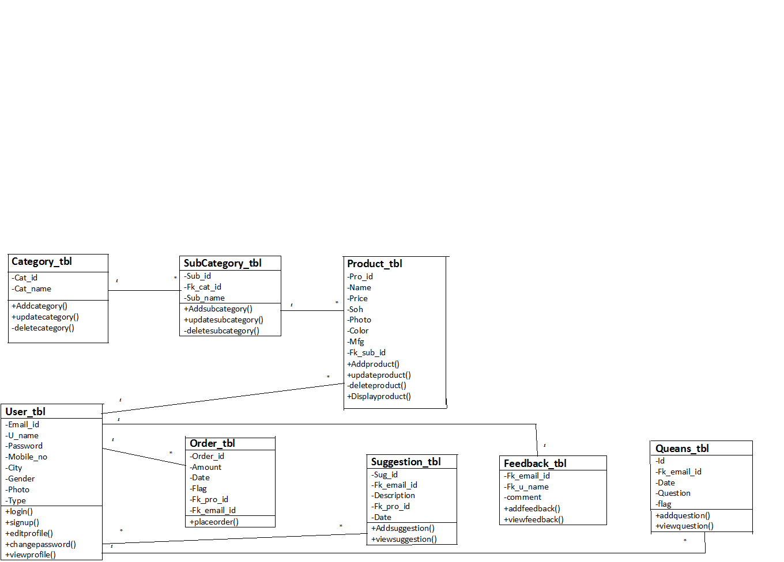

**4.1 SystemFlow Diagram**



**5. Data Dictionary**

1. User Table :-

|  |  |  |  |  |
| --- | --- | --- | --- | --- |
| Field Name | Data Type | Size | Constraints | Description |
| Email_id | Varchar | 50 | Primary key | It will save email ID. |
| U_name | Varchar | 50 | Not Null | It will store user’s name. |
| Password | Varchar | 10 | Not Null | Password will be unique. |
| Mobile_no | Integer | 10 | Not Null | It will store user’s mobile number. |
| City | Varchar | 10 | Not Null | It will store the name of city where user leaves. |
| Gender | Varchar | 6 | Not Null | It has 2 values– male or female. |
| Photo | Varchar | 500 | Allow Null | It will store user’s profile picture. |
| Type | Varchar | 10 | Not Null | 2 types of user : customer or admin. |

1. Category Table :-

|  |  |  |  |  |
| --- | --- | --- | --- | --- |
| Field Name | Data Type | Size | Constraints | Description |
| Cat_id | Integer | 10 | Primary Key | It will save the category ID. |
| Cat_name | Varchar | 50 | Not Null | It will store the category name. |

1. Product Table :-

|  |  |  |  |  |
| --- | --- | --- | --- | --- |
| Field Name | Data Type | Size | Constraints | Description |
| Pro_id | Integer | 10 | Primary Key | It will save product ID. |
| Name | Varchar | 50 | Not Null | It will store name of the product. |
| Price | Varchar | 10 | Not Null | It will store price of the product. |
| Soh | Integer | 10 | Not Null | It will store stock of the product. |
| Photo | Varchar | 500 | Not Null | It represent product image. |
| Color | Varchar | 10 | Not Null | It will store color of the product. |
| Fk_cat_id | Integer | 10 | Foreign Key | It will reference to the category table. |
| Mfg | Varchar | 50 | Allow Null | It will store manufacturing information. |

1. Video Table :-

|  |  |  |  |  |
| --- | --- | --- | --- | --- |
| Field Name | Data Type | Size | Constraints | Description |
| Id | Integer | 10 | Primary Key | It will save the video ID. |
| Image | Varchar | 500 | Not Null | It will store the video image. |
| Video | Varchar | 500 | Not Null | It will store the video. |

1. Order Table :-

|  |  |  |  |  |
| --- | --- | --- | --- | --- |
| Field Name | Date Type | Size | Constraints | Description |
| Order_id | Integer | 10 | Primary Key | It will store the order ID. |
| Amount | Varchar | 10 | Not Null | It will store the amount  Of the order. |
| Date | Date | 10 | Not Null | It will store the date when order is placed. |
| Qty | Integer | 10 | Not Null | It will store the quantity of the product. |
| Flag (Status) | Varchar | 10 | Allow Null | It will shows the product is buy or in the cart. |
| Fk_pro_id | Integer | 10 | Foreign key | It will reference to the product table. |
| Fk_email_id | Varchar | 50 | Foreign key | It will reference to the user table. |

1. Feedback Table :-

|  |  |  |  |  |
| --- | --- | --- | --- | --- |
| Field Name | Data Type | Size | Constraints | Description |
| Fk_email_id | Varchar | 20 | Foreign Key | It will store email id. |
| Fk_u_name | Varchar | 20 | Foreign Key | It will store the user name. |
| Comment | Varchar | 50 | Not Null | It will save the feedback of user. |

1. Suggestion Table :-

|  |  |  |  |  |
| --- | --- | --- | --- | --- |
| Field Name | Data Type | Size | Constraints | Description |
| Sug_id | Integer | 10 | Primary Key | It will store suggestion Id. |
| Fk_email_id | Varchar | 50 | Foreign Key | It will reference to user table. |
| Description | Varchar | 100 | Not Null | It shows the information related to the product. |
| Fk_pro_id | Integer | 10 | Foreign Key | It will reference to product table. |
| Date | Varchar | 10 | Not null | It will store the date. |

1. Que-Ans Table :-

|  |  |  |  |  |
| --- | --- | --- | --- | --- |
| Field Name | Data Type | Size | Constraints | Description |
| Id | Integer | 10 | Primary Key | It will store the question number. |
| Fk_email_id | Varchar | 50 | Foreign Key | It will reference to user table. |
| Date | Date | 10 | Not Null | It will store the date when question is ask. |
| Question | Varchar | 100 | Not Null | It will store the question which is asked by user. |
| Flag | Varchar | 5 | Not Null | It will store the flag. |

1. Answer Table :-

|  |  |  |  |  |
| --- | --- | --- | --- | --- |
| Field Name | Data Type | Size | Constraints | Description |
| Id | Integer | 10 | Primary key | It will store the answer id. |
| Fk_email_id | Varchar | 50 | Foreign Key | It will reference to user table. |
| Fk_id | Integer | 10 | Foreign Key | It will reference to queans table. |
| Date | Date | 10 | Not Null | It will store the date of the answer. |
| Answer | Varchar | 100 | Not Null | It will store the answer which is given by the user. |
| Flag | Varchar | 10 | Not Null | It will store the Flag. |

1. Subcategory Table :-

|  |  |  |  |  |
| --- | --- | --- | --- | --- |
| Field Name | Data Type | Size | Constraints | Description |
| Sub_id | Integer | 10 | Primary key | It will store the sub category id. |
| Fk_cat_id | Integer | 10 | Foreign Key | It will reference to category table. |
| Sub_name | Varchar | 50 | Not Null | It will store the sub category name. |

1. **Input-Output Design**

* **Home Page :**

This page is the first page of website. In this page user will show the image

s of the gifts and user can login in the system. New user can register in the system.

User can contact with the admin. User can give their feedback for the system. User can also follow this gift shop on Gmail, Facebook and Instagram.

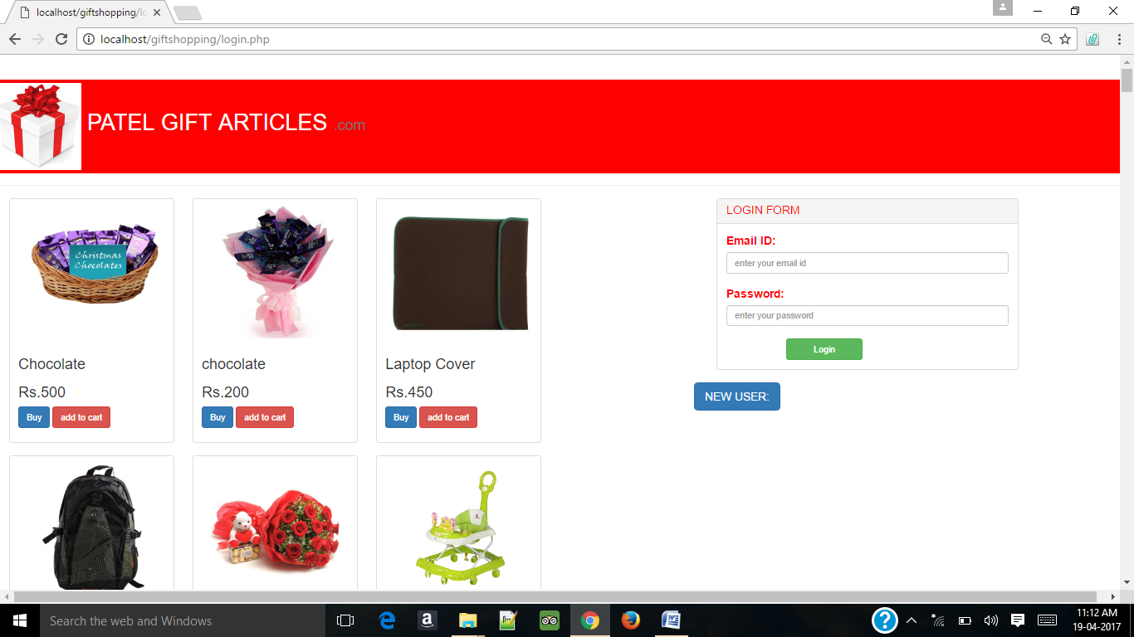

* **User Home Page :**

This page is display when user login in the system. In this page user find more options for gifts. User can search the gifts.

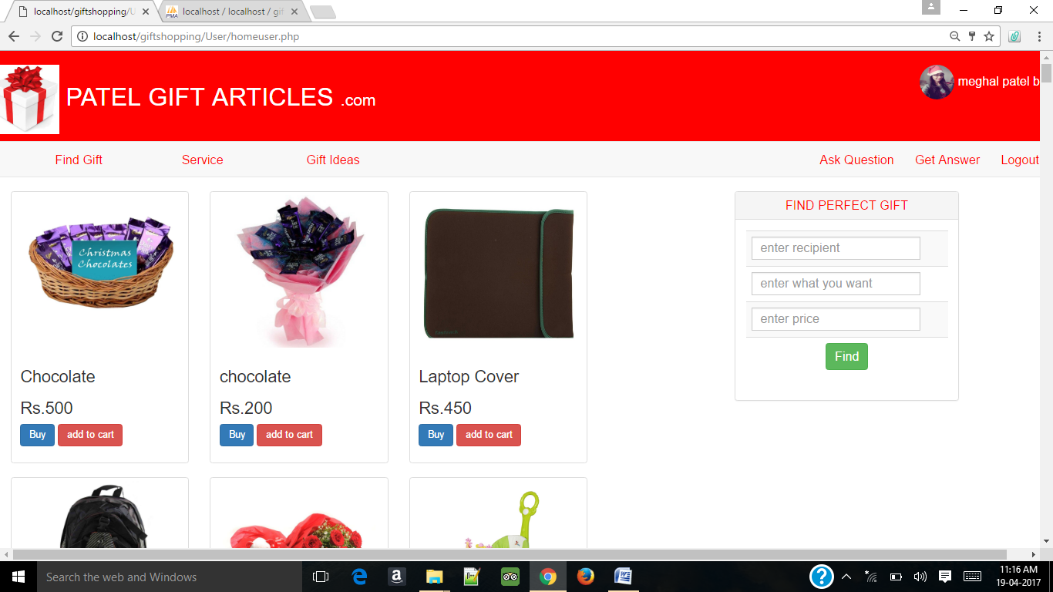

* **Find Gifts Page :**

In This page user can finds the gifts by different categories. User can find the gifts by recipient, occasions and personality. User can also add the gifts in the cart which he or she likes. User can also ask the questions about the gifts.

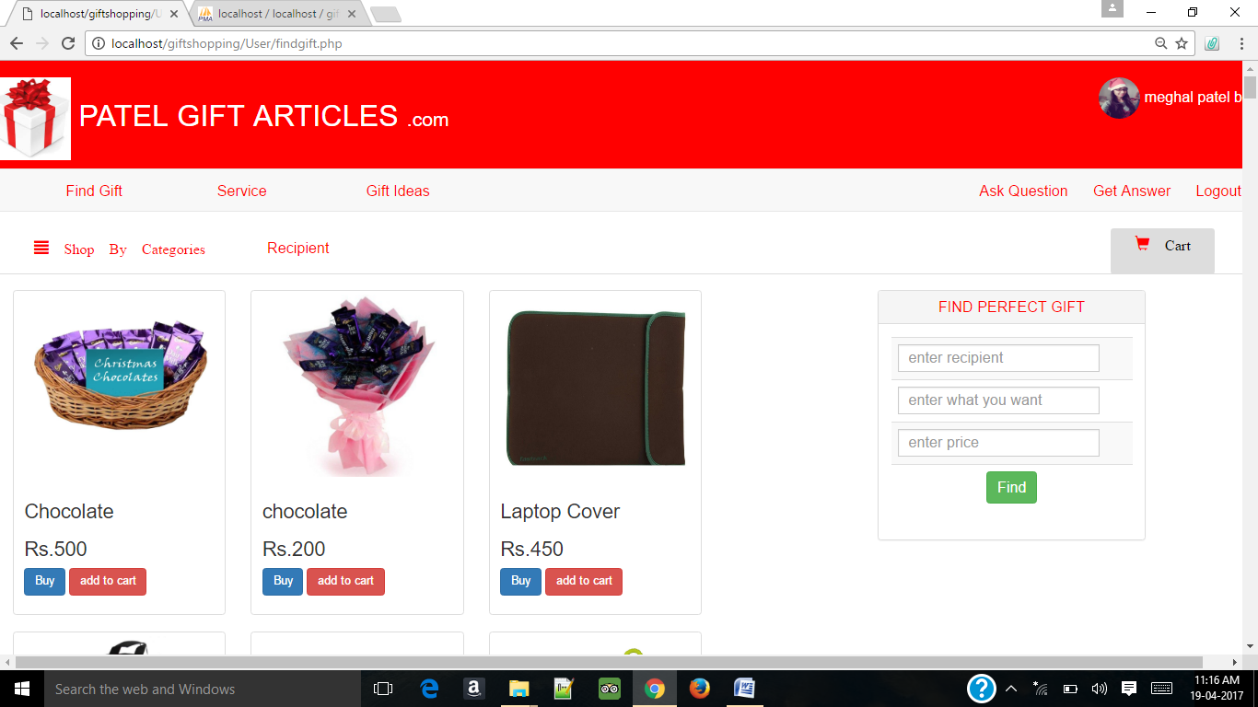

* **Services Page :**

In this page user can show thier services given by this system. User can add the gifts which he or she wishes to buy. User can create cards and send it by email. User can also show events.

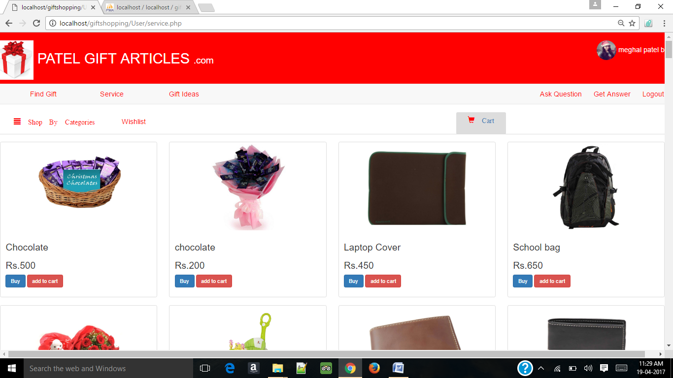

* **Gift Ideas Page:**

In this page user can create personalised gifts which he or she wants. User can also show the top gifts of the shop.

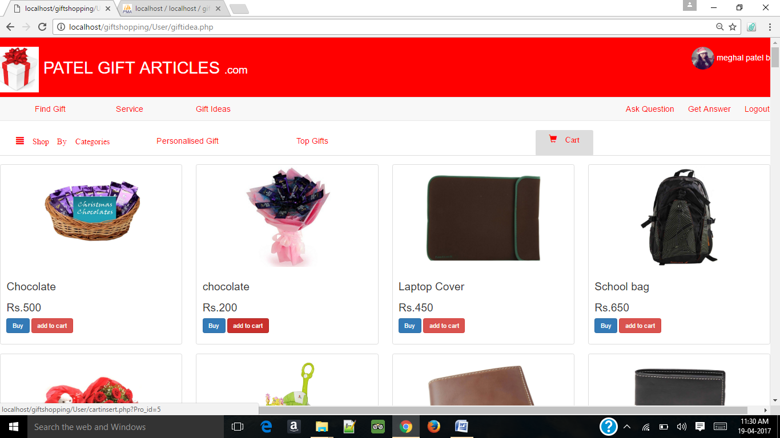

* **After Choose Category Page:**

In this page user can show all the category list. User can also show full image of gifts. User can buy gifts by clicking buy button and also add the gifts in the cart. User can sort the gifts by name and price.

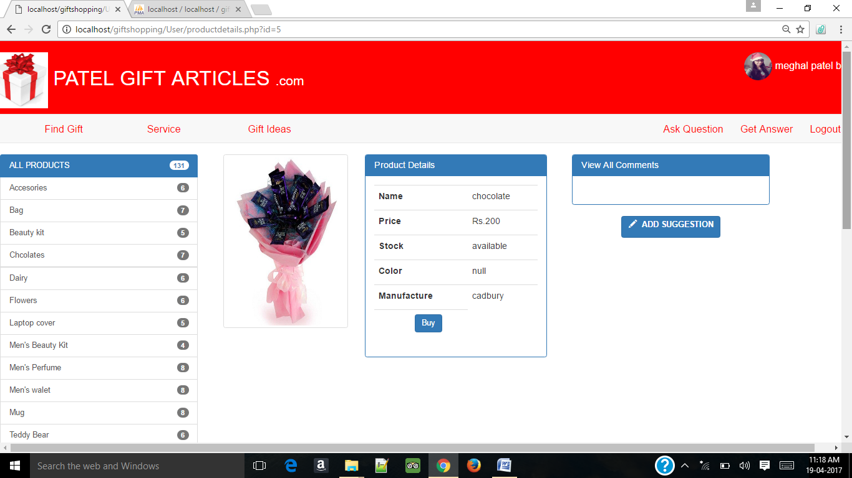

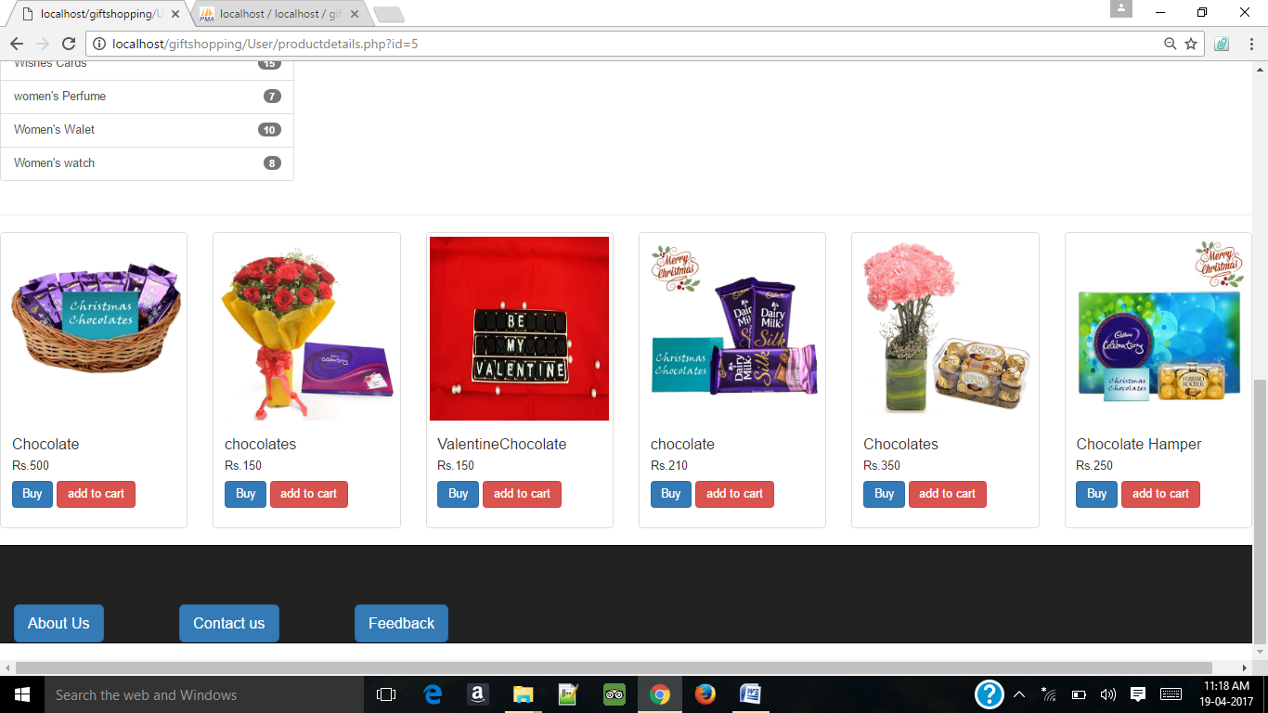

* **After Recipient :**

In this page user can show top matching gifts by the recipient. User can also find the gifts below Rs.500 , Rs.1000 and Rs.1500 .

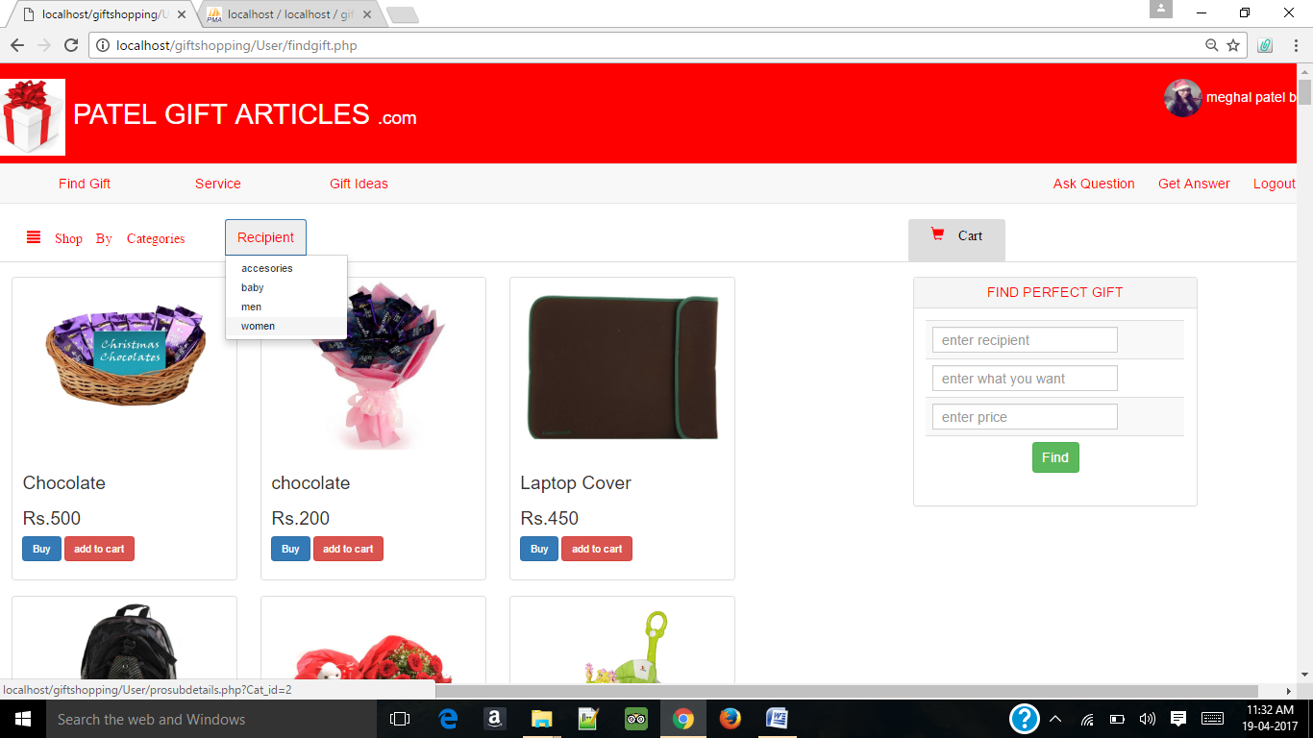

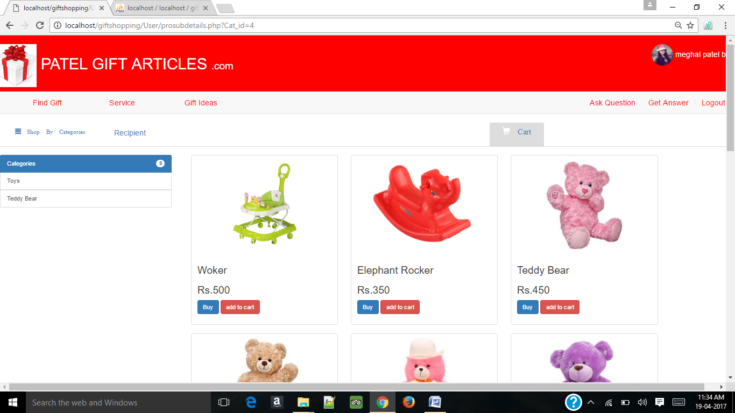

* **User Profile Page :**

In this page, user can show different user pages like profile, edit profile, change password, Forget password and my orders. User can show their profile.

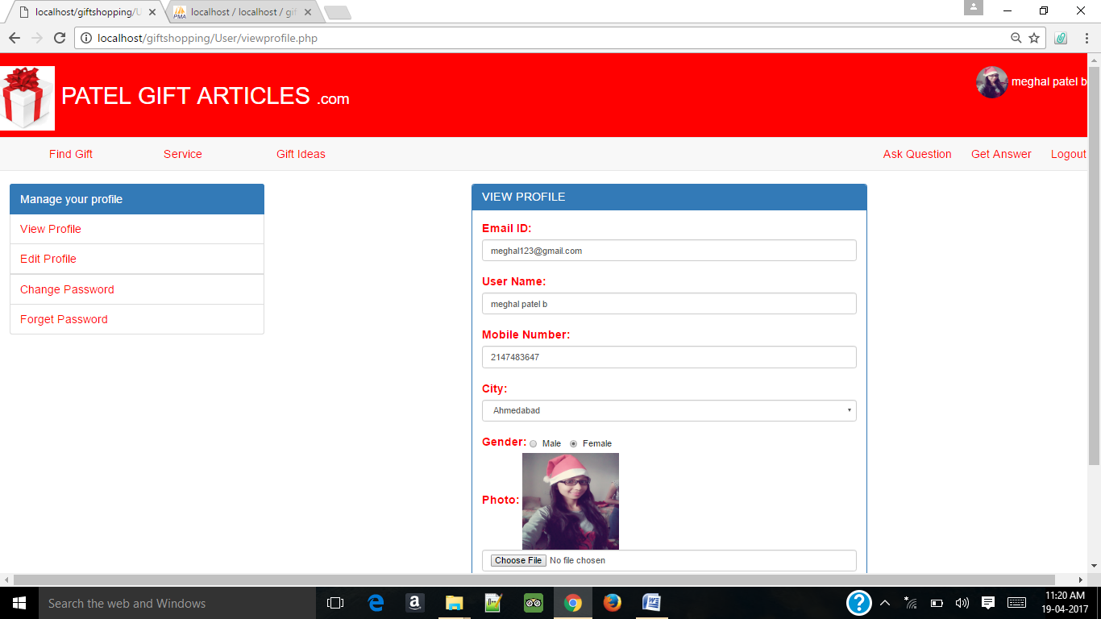

* **Top Gift Page :**

User can buy gifts between different price crieteria.

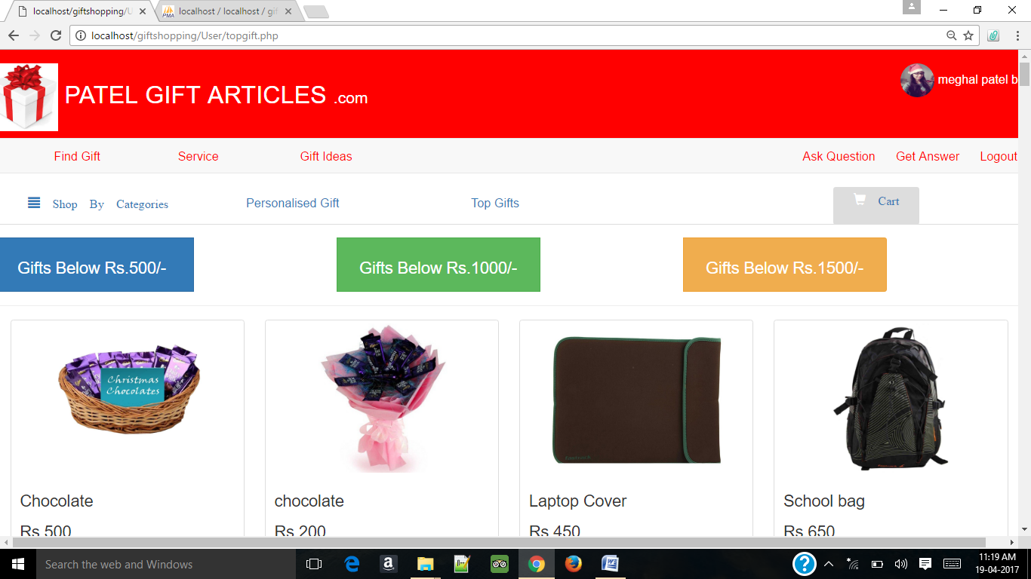

* **Personalised Gift Page :**

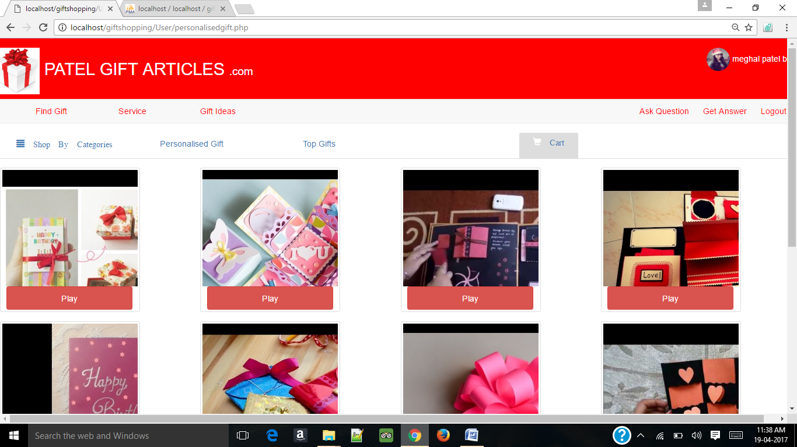

* **Wishlist Page:**

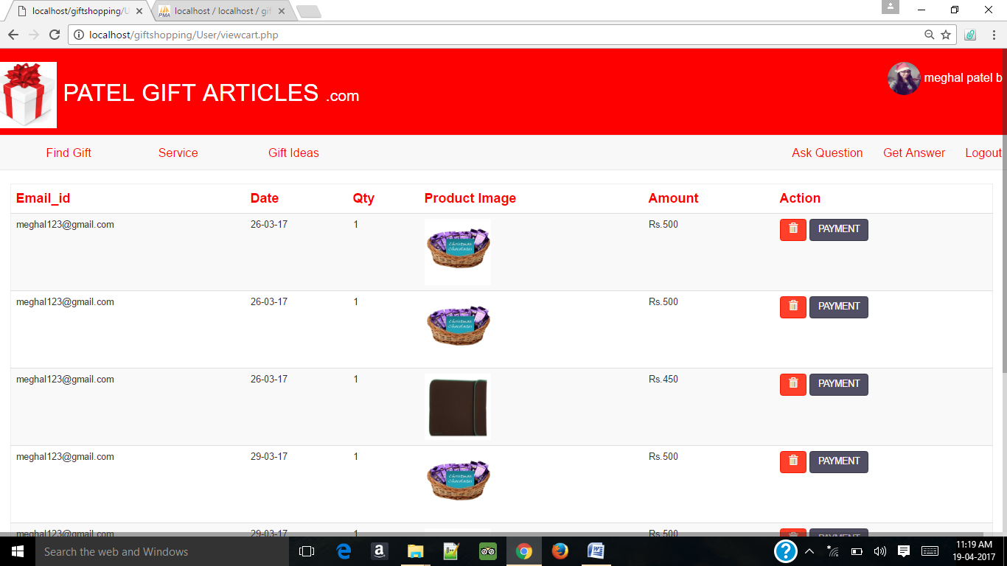

* **Ask Question Page:**

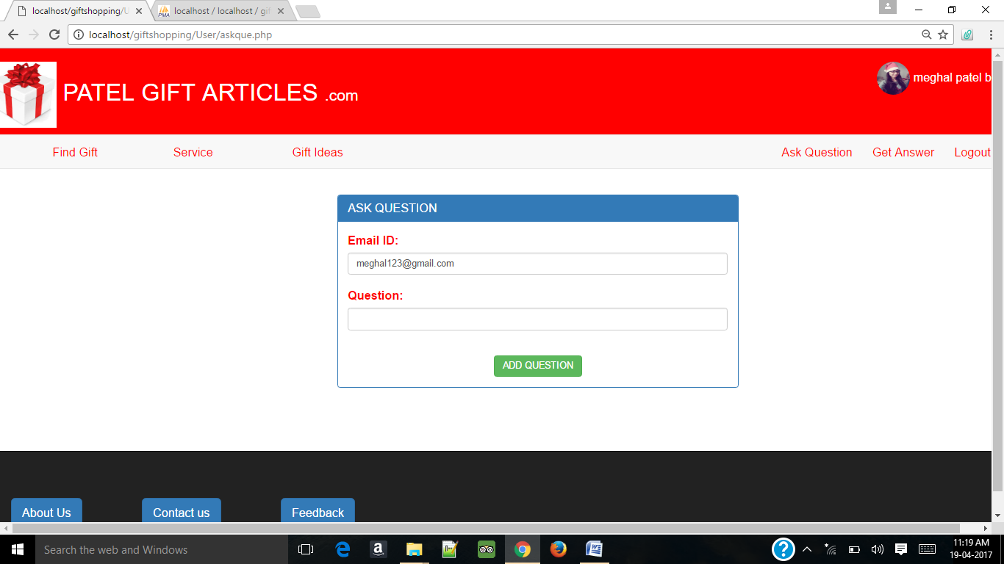

* **Get Answer Page :**

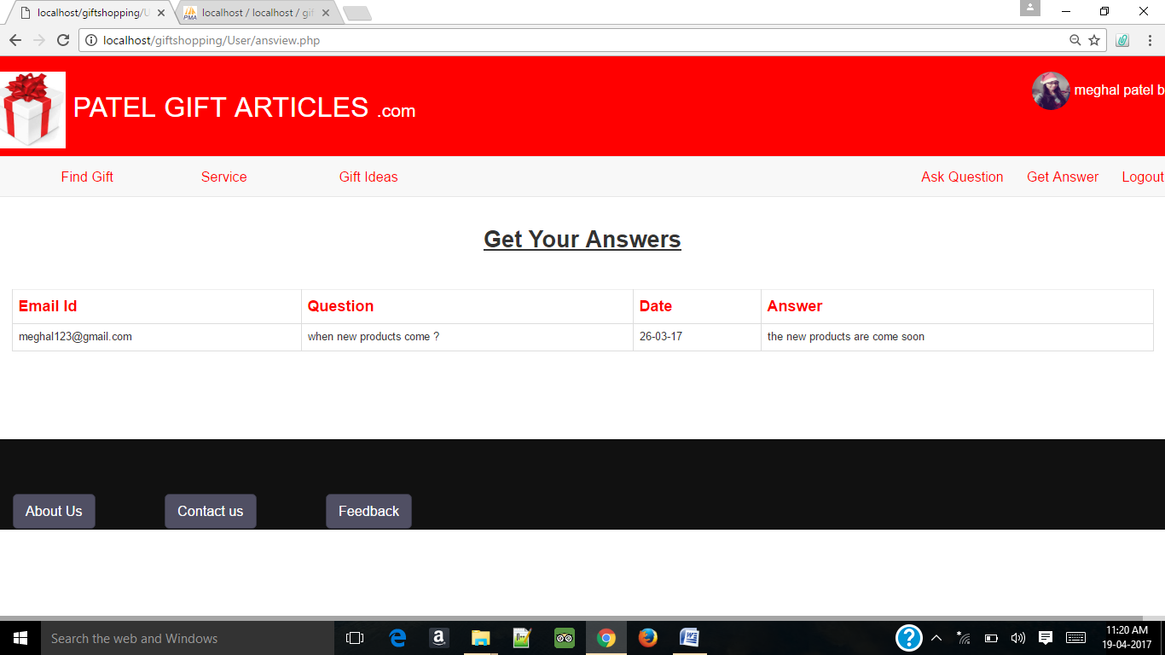

1. **Validation:**

* Login Page:

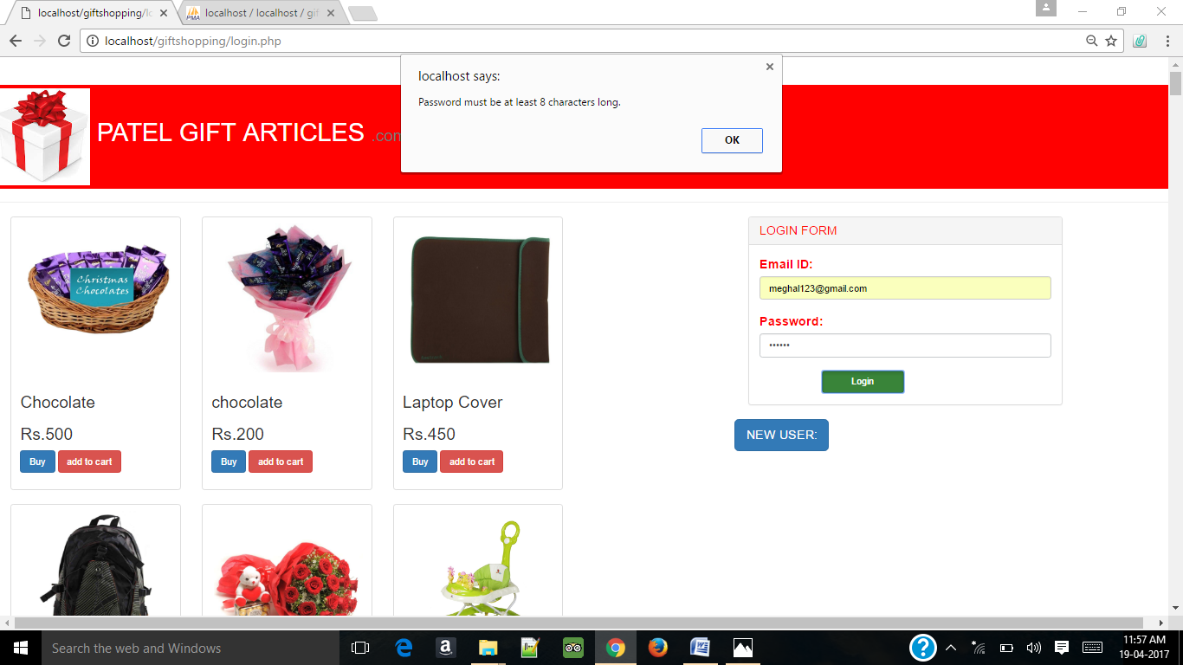

* Signup Page🡪 Email :

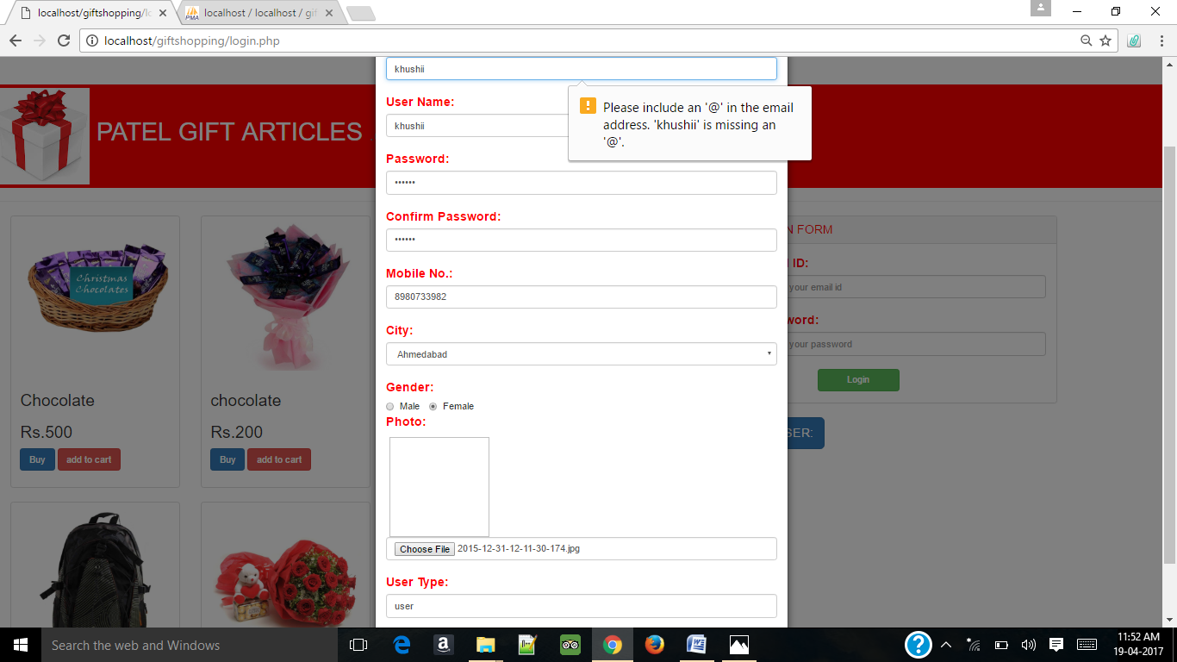

* Password :

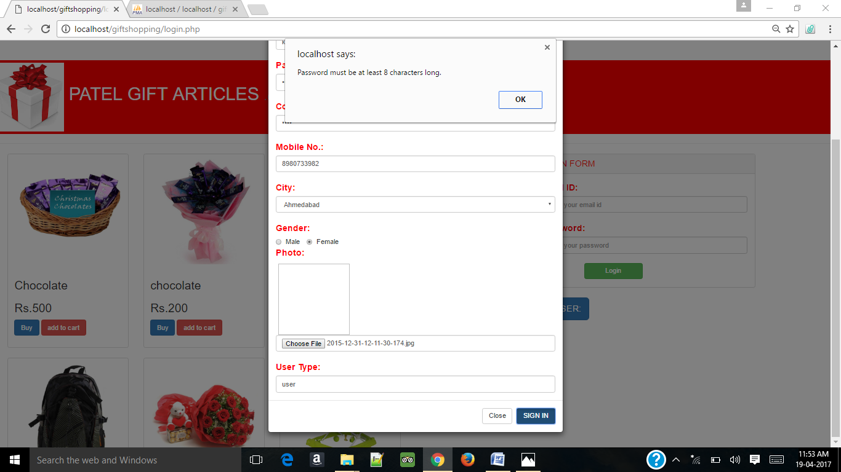

* User Name:

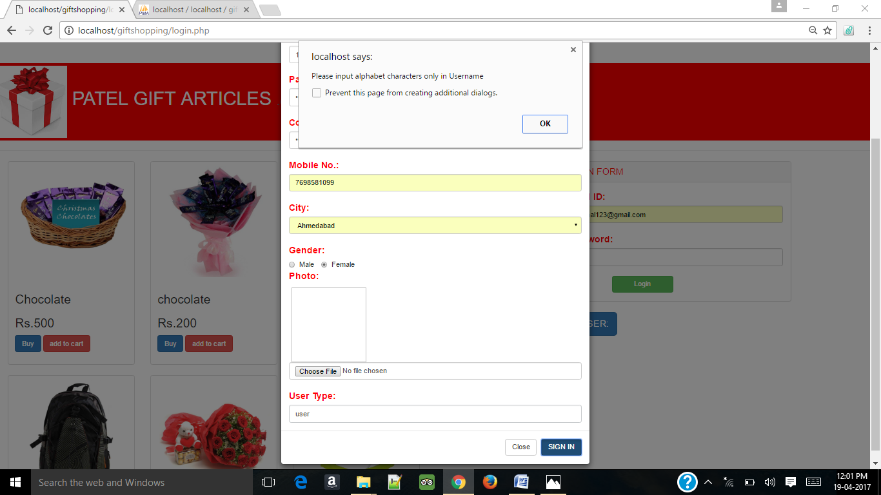

**8. Maintenance Form:**

# Patel Gift Articles

# Maintenance Form

**Date: ____________**

**Name: _____________________________________________**

**Address: ____________________________________________**

**Phone Number: ______________________________________**

**Email Address: _______________________________________**

**Nature of Problem: ___________________________________**

**Item Affected: _______________________________________**

**Location of Problem: __________________________________**

**Description of work required: ___________________________**

**____________________________________________________**

**____________________________________________________**

**9. Future Scope:**

* We develop this web application after making analysis about the existing problem which the people are facing.
* Although no project can be termed as a perfect in real sense there and there is always remains scope for further Improvement and so that it helps to develop a new version.
* We are always eager to know some new gifts and new gift ideas related to this project.
* The main objective of online gift shopping system is to enhance and upgrade the existing system by increasing its efficiency and effectiveness.
* The software improves the working methods by replacing the existing manual system with the computer-based System.
* Today, use of hi-tech devices like cellular phones, palm top computers and tablet PCs have become common. This system in future can also be incorporated into mobile application to make it easily accessible by users.

**Bibliography:**

* **Reference used for the UML diagram :**

1. Software Engineering A Practitioner’s Approach 7th Edition by Roger S. Pressman.

* **Web sources that were used for the Project are:**
  + - [www.stakeoverflow.com](http://www.stakeoverflow.com)
    - [www.google.com](http://www.google.com)

.